SET-12 — Website Traffic Analysis
AIM
To analyze website traffic data and visualize page views, click-through rates, and daily website traffic using R programming.
ALGORITHM
- Start RStudio.
- Create the Website Traffic dataset.
- Convert Date into Date format.
- Create a line chart for daily page views.
- Create a bar chart for the top days based on click-through rate.
- Display the website traffic data in a table.
- Add suitable titles and labels.
- Display the output.
- Stop.
R CODE
website<-
data.frame
(Date=as.Date(c("2023-01-01","2023-01-02","2023-01-03")),Page_
Views=c(1500,1600,1400),Click_
Through_Rate=c(2.3,2.7,2.0))
plot(website$Date,website$Page_Views,type="o",main="Daily
Page Views Trend",xlab="Date",ylab="Page Views")
top<-website
[order(-website$Click_Through_Rate),][1:3,]
barplot(top$
Click_Through_Rate,names.arg=as.character
(top$Date),
main="Top Days by Click-Through Rate
",xlab="Date",ylab="
Click-Through Rate (%)")
website

OUTPUT
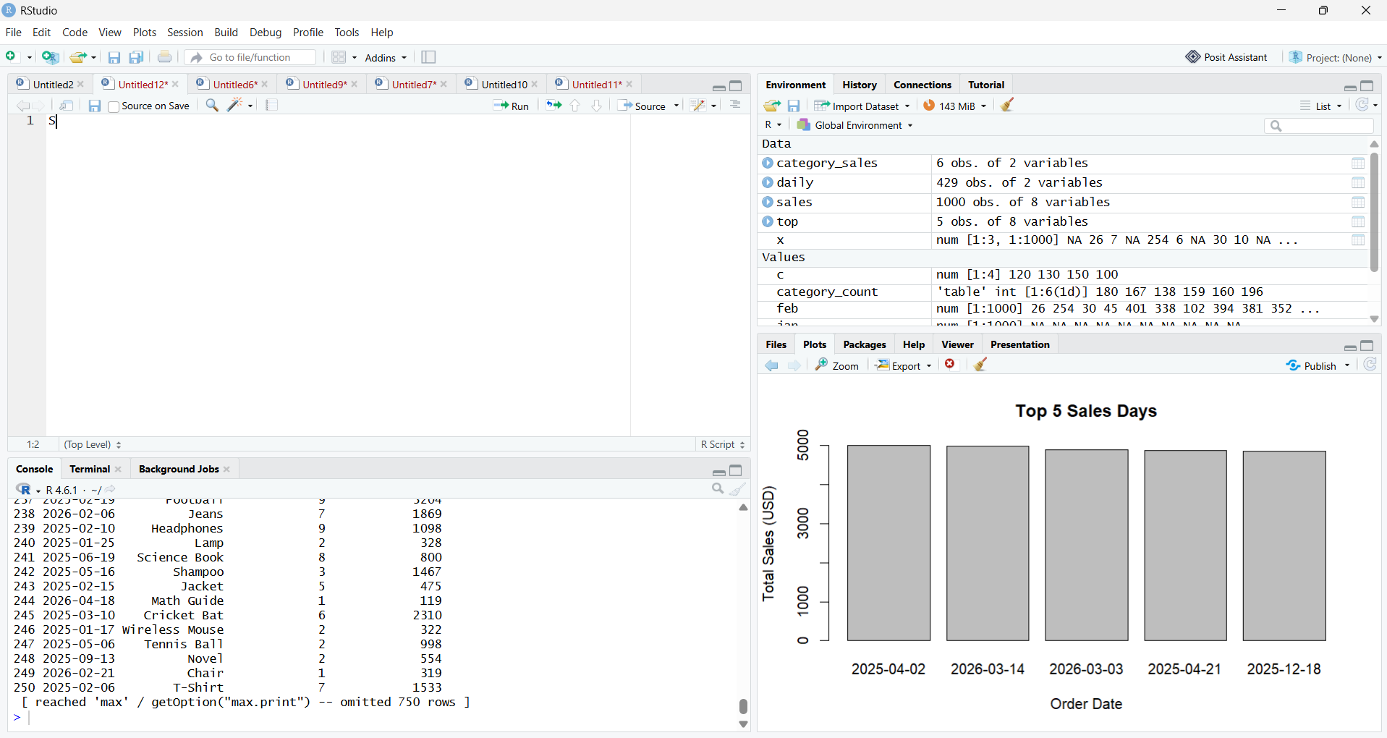RESULT
Thus, the Website Traffic data was successfully analyzed using R programming. The line chart, bar chart, and website traffic table were successfully created.

